Exercise 01-01
The result should display as such:
Hi my name is [First Name] [Last Name].
I am in [grade level].
I have [number] siblings.
My birthday is [birthdate].
Exercise 01-02
Create a variable txt with the value "Hello, World!"
Print the characters from index 2 to 5.
Print the variable txt converted to upper case.
Create a variable name with the value "Python".
Use an f-string to print "I love Python" using the name variable.
Exercise 01-03
Using the first letter of your name spell “Hello World”. For example, if your name starts with a B the result would be as such:
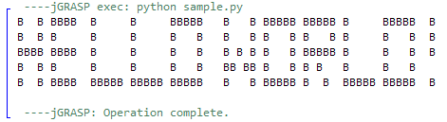

Exercise 01-04
Convert the following mathematical expressions so that they can be calculated using the Python interpreter. Print the result to the console.
10 + 20 × 30
42 ÷ 30
(94 + 2) × 6 – 1
Display each equation in the console as such, followed by the result of the equation:
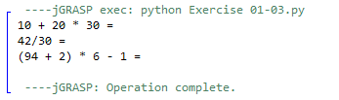
Exercise 01-05
Write a program to calculate the area of a triangle. The program shall take the base and height of the triangle as input from the user and display the result as such:
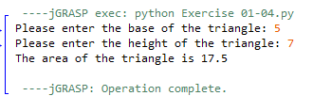
Exercise 01-06
Write a program that calculates the sum of three variables and prints the result. The program will accept three numbers for the user and display the result as such:
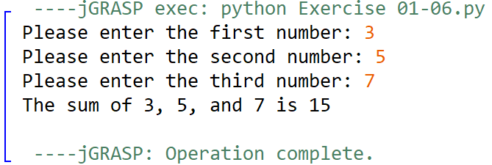
Exercise 01-07
Using the code you wrote in exercise 01-07, rework the logic to calculate the average of three numbers. Round the result to two decimal places.

Exercise 01-08
Write a program to determine the number of students in a group given the total number of students and the number of groups. The program will take accept to numbers from the user and assign them to variable representing the total numbers of students and the total number of students.
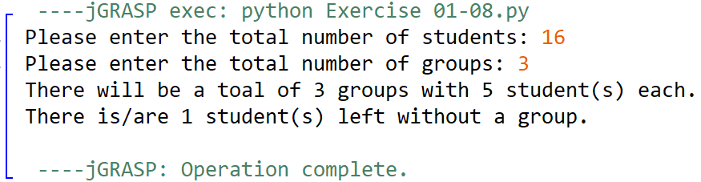
Exercise 01-09
Write a program that takes the user’s name and their monthly rent and calculates their yearly rent. Use f-strings or concatenation to address the user by their name.
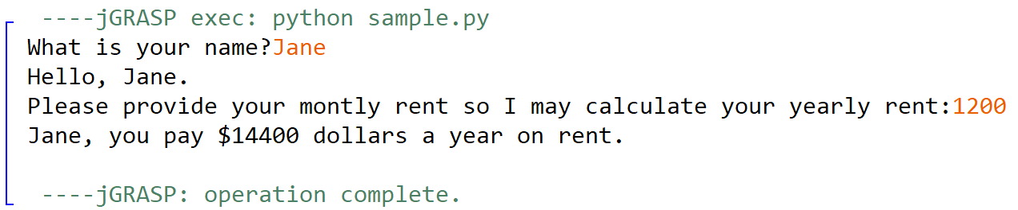
Exercise 01-10
Write a program that counts the number of letters in someone’s name. Make sure to account for spaces if the user provides their first and last name. Make use of the len() function and replace() method.
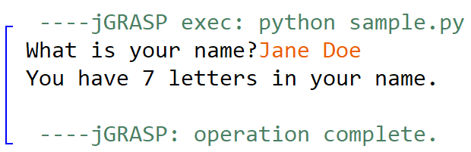.

Stretch Assignments:
If you complete the previous exercises, I encourage you to attempt the stretch assignments below. These assignments require concepts that I have yet to cover. Research if statements and loops using the Python documentation.
Exercise 01-11
Write a program that accepts a string from the user. In the console display only the characters which are present at an even index number in the given string.
Exercise 01-12
Write a choose your own adventure game that plays in the console. Allow the user to provide input to select their path. Explore if statements to create different endings. Assign variables to keep track of progress, such as HP or in game currency.

